Software Requirements Specification (SRS)
Project Name: CareCompanion: Modular Whole-Eye AI Diagnostic & Education System
Version: 1.0 | Date: March 2026
1.1 Purpose
Globally, a staggering number of patients experience preventable vision loss every day simply due to a lack of understanding and early awareness regarding their ocular conditions.Version 2.0 expands the original ophthalmic diagnostic and education platform by incorporating a fully integrated Intelligent Document Parsing (IDP) Agent subsystem, developed in response to the Databricks/Virtue Foundation Hackathon challenge The CareCompanion project aims to combat this crisis by bridging the information gap, providing patients with accessible, personalized education and diagnostic insights to empower them throughout their healthcare journey.
Intelligent Healthcare Routing & Capability Verification: To empower patients with verifiable, transparent data regarding local healthcare facilities. The system will analyze hospital capabilities, equipment availability, and specialist presence to match patients with the most appropriate care centers for their specific conditions, reducing wasted time and financial resources during critical or emergency situations.
In service of this mission, the purpose of this Software Requirements Specification (SRS) is to establish the complete architectural, functional, and security baseline for the CareCompanion: Modular Whole-Eye AI Diagnostic & Education System. The combined system serves two cohesive purposes: (1) empower individual patients with AI-driven ophthalmic diagnostics, personalised educational media, and transparent facility recommendations; and (2) serve NGO planners and healthcare coordinators — such as those operating under the Virtue Foundation — with an agentic intelligence layer that maps regional medical capability, exposes medical deserts, and verifies facility claims at scale.This document dictates the strict rules, system behaviors, and design requirements for the platform, serving as the official blueprint to guide developers, engineers, and Quality Assurance (QA) teams during the building and testing phases.

1.2 Scope:
We describe what features are in the scope of the software and what are not in the scope of the software to be developed.
In Scope:
a. Analyzing uploaded patient symptoms and eye images (e.g., OCT, CFP) using AI vision models.
b. Generating automated text-based medical reports from the scan results.
c. Creating personalized educational videos from the text reports using AI image and video generation tools.
d. Providing a secure, localized online vault for patients to store and manage their reports.
- e. User authentication and secure role-based access for the platform.
Geospatial Emergency Assistance: location-based identification of the nearest verified facilities, steering patients away from medical deserts.
- [NEW v2.0] Intelligent Document Parsing (IDP) Agent: extracting and verifying medical facility capabilities from free-form, unstructured text fields (procedure, equipment, capability columns) using a RAG + Agentic workflow.
- [NEW v2.0] Medical Desert Detection: identifying regions where critical medical expertise is absent or understated, enabling NGO resource allocation decisions.
- [NEW v2.0] Facility Anomaly Detection: flagging suspicious or incomplete capability claims in hospital profiles.
- [NEW v2.0] Agentic Planning System: a multi-step reasoning pipeline accessible to non-technical NGO planners via natural language.
- [NEW v2.0] Row-level and agentic-step-level Citations: tracing every agent claim back to the specific source data row that supported it, tracked via MLflow.
- [NEW v2.0] Geospatial Map Visualisation: rendering a live map of facility capability coverage and gap regions.
f. Facility Capability Mapping: The system will move beyond patient diagnosis to include facility analysis. It will process and cross-reference facility data to verify if a hospital possesses the necessary physical infrastructure (e.g., specific imaging machines, operating rooms) and personnel to treat the patient's analyzed condition.
g. Geospatial Emergency Assistance: The application will incorporate location-based logic to identify the nearest verified facilities, effectively steering patients away from "medical deserts" or facilities that lack the specialized equipment required for their care.

Out of Scope:
a. Direct integration with hardware devices (like actual OCT or Slit-Lamp machines) to capture live images; the system only accepts pre-captured uploads.
b. Processing patient data through external or third-party cloud APIs (all AI models must run locally for security).
- c. Providing certified medical treatment plans or acting as a definitive replacement for human ophthalmologists.
Tracking individual doctor movements or personal medical credentials beyond facility-level data.

1.3 Definitions, Acronyms, and Abbreviations:
Acronyms and Abbreviations:
a. SRS: Software Requirements Specification.
b. AI: Artificial Intelligence.
c. LLM: Large Language Model.
d. OCT: Optical Coherence Tomography (a type of eye scan).
e. CFP: Color Fundus Photography (a picture of the back of the eye).
f. GUI: Graphical User Interface.
IDP | Acronym | Intelligent Document Parsing
RAG | Acronym | Retrieval-Augmented Generation
RBAC | Acronym | Role-Based Access Control
NGO | Acronym | Non-Governmental Organisation
VF | Acronym | Virtue Foundation — the partner NGO providing real-world facility datasets

MLflow | Tool | Open-source ML lifecycle and experiment tracking platform (Databricks)
FAISS | Tool | Facebook AI Similarity Search – vector similarity library for RAG
LanceDB | Tool | Open-source embedded vector database optimised for AI workloads
LangGraph | Tool | Graph-based LLM orchestration framework for agentic workflows
LlamaIndex | Tool | Data framework for LLM applications, specialised for RAG pipelines
CrewAI | Tool | Role-based multi-agent orchestration framework
Genie / Text2SQL | Tool | Databricks natural language to SQL query interface
ComfyUI | Tool | Node-based visual interface for routing FLUX.2 → Wan 2.2 pipeline
Pydantic | Tool | Python data validation library used to enforce facility schema integrity

Definitions:
a. Slit-Lamp: A specialized microscope with a high-intensity light source used during eye exams to evaluate the front structures of the eye.
b. Topography Map: A computerized imaging technique that maps the surface curvature of the cornea.
c. RETFound-Green: A specialized artificial intelligence vision model used within the system to analyze scans of the back of the eye.
d. ResNet-50: A specific type of deep learning neural network used in this system to evaluate images of the front of the eye.
e. Flux-klien: An open-source AI model utilized by the system to generate custom medical illustrations and pictures based on text descriptions.
f. Wan 2.2: An open-source Image-to-Video (I2V) AI model used to animate static pictures into educational video clips.
g. ComfyUI: A node-based visual interface used by the backend to route and connect the image generation process directly into video creation.
h. Safe Document Vault: A secure, encrypted digital storage space within the patient portal where users can upload, tag, and manage their past medical reports|
Medical Desert | Definition | A geographic region where patients cannot access the critical medical specialties or equipment required to treat their condition within a feasible travel time
IDP Agent | Definition | An autonomous AI agent that reads unstructured documents, extracts structured medical facility data, verifies claims, detects anomalies, and reasons over gaps
.
RETFound-Green | Model | Localised AI vision model for retinal scan analysis
ResNet-50 | Model | Deep learning CNN for anterior segment ophthalmic image classification
FLUX.2 | Model | Open-source image generation model for medical illustration creation
Wan 2.2 | Model | Open-source Image-to-Video (I2V) model for educational video animation

1.4 References:
External Documentation:
a. ABDM (Ayushman Bharat Digital Mission) Sandbox Documentation for healthcare data standards and secure vault architecture.
b. IEEE Recommended Practice for Software Requirements Specifications (IEEE Std 830-1998).
- c. Official open-source documentation for FLUX.2, Wan 2.2, ComfyUI, and RETFound-Green.
Databricks/Virtue Foundation Hackathon Brief — Bridging Medical Deserts: Building IDP Agents (2026).
- Virtue Foundation Ghana Dataset & Schema Documentation (official field definitions for facility data extraction).
- MLflow Documentation — Experiment Tracking & Traceability (mlflow.org).

Internal Appendices:
a. Appendix A: AI Model Output Formats (Details the expected JSON/Text outputs from the Vision and LLM models).
b. Appendix B: Video Generation Pipeline Flow (Diagram and rules for converting text to FLUX.2 images and Wan 2.2 video).
- c. Appendix C: User Screens (UI Mockups for the React Patient Portal and Streamlit Admin Dashboard).
Appendix D — IDP Agent Architecture & Agentic Reasoning Flow [NEW v2.0].
- Appendix E — Facility Schema: All Columns and Definitions [NEW v2.0].
- Appendix F — MLflow Citation Traceability Schema [NEW v2.0].

1.5 Overview:
The rest of this SRS is organized as follows: Section 2 gives an overall description of the software. It gives what level of proficiency is expected of the user, some general constraints while making the software and some assumptions and dependencies that are assumed. Section 3 gives specific requirements which the software is expected to deliver. Functional requirements are given by various use cases. Some performance requirements and design constraints are also given. Section 4 gives some possible future extensions of the system. Finally, the appendices in Section 5 describe respectively the AI model output formats, the video generation pipeline flow, and the user screens.
2.1 Product Perspective:
CareCompanion is aimed toward patients who need clear, accessible explanations of their complex ophthalmic scans (such as OCT, CFP, and Slit-Lamp images) and a secure, centralized space to manage their medical history. CareCompanion should be a highly secure, user-friendly, and educational platform for the above purpose.
CareCompanion is intended to be a web-based application consisting of a React frontend and a Flask/Python backend. To strictly comply with medical data privacy, the system is designed so that all AI processing (including the RETFound-Green vision models, FLUX.2 image generation, and Wan 2.2 video generation) runs entirely on a secure local server rather than depending on external, third-party cloud APIs. The user-facing patient portal should be accessible via standard web browsers across any operating system (Windows, macOS, Linux, or mobile platforms).
CareCompanion v2.0 is a web-based, multi-subsystem platform composed of two tightly integrated layers:
- Patient Intelligence Layer: The original ophthalmic diagnostic and educational interface — a React/Flask application where patients upload scans, receive AI-generated reports and videos, chat with the AI Director, and manage their secure document vault.
- Healthcare Coordination Intelligence Layer [NEW v2.0]: An agentic IDP pipeline — directly inspired by the Databricks/Virtue Foundation Hackathon problem statement — that ingests unstructured facility data, extracts structured capability records, detects medical deserts and anomalies, and presents actionable coordination recommendations to NGO planners.

All heavy AI processing (vision models, video generation, IDP agent reasoning loops) executes on a secure local backend. Only sanitised, non-identifying clinical text is forwarded to external LLM APIs (Groq / Llama 3.1). The system is accessible via standard web browsers on any platform.

2.2 Product Functions

Class of Use Cases | Use Cases | Description of Use Cases
Diagnostic Functions | Retinal Analysis | Processing back-of-the-eye scans (e.g., OCT, CFP) using the localized RETFound-Green model to detect abnormalities.
 | Anterior Segment Analysis | Processing front-of-the-eye scans (e.g., Slit-Lamp) using custom ResNet-50 models to identify surface conditions.
Educational & Chat Functions | The Director (AI Chat & Scripting) | Utilizing an LLM (via Groq API / Llama 3.1) to analyze clinical conditions, answer patient queries, and dynamically construct relevant educational YouTube search links.
 | Generative Media Creation | Automatically converting medical text into personalized educational videos using FLUX.2 (image generation) and Wan 2.2 (video animation).
Data & Document Management | Secure Document Storage | Storing and managing user accounts, medical reports, and system data using Supabase cloud infrastructure within a protected patient portal.
 | Document Parsing | Allowing users to upload medical documents (PDFs) and extracting the text securely for AI analysis using the PyPDF2 library.
Utility & Portal Functions | Appointment Management | Organizing and sorting patient schedules and upcoming appointments using a custom backend sorting algorithm.
 | Real-Time Interactions | Providing instant system feedback and live updates between the React frontend and Flask backend using WebSockets (SocketIO).
[NEW] IDP Agent | Unstructured Feature Extraction | Extract procedure, equipment, capability fields from free-form hospital notes using RAG + LLM agent.
[NEW] IDP Agent | Intelligent Synthesis | Merge unstructured insights with structured facility schemas for a unified regional capability view.
[NEW] IDP Agent | Medical Desert Detection | Identify geographic regions where required specialties or equipment are absent.
[NEW] IDP Agent | Facility Anomaly Detection | Flag suspicious capability claims (e.g., surgery listed without OR equipment).
[NEW] IDP Agent | Agentic Planning System | Natural language interface for NGO planners to query facility data and receive step-by-step action plans.
[NEW] IDP Agent | Geospatial Map Visualisation | Interactive map rendering of facility coverage, capability gaps, and medical deserts.
[NEW] IDP Agent | Citation & Traceability | Row-level and agentic-step-level citations logged via MLflow for full audit trail.

2.3 User Characteristics:
a. The primary user (patient) should possess basic computer literacy, including the ability to navigate a web browser, log into a secure portal, and upload digital files (such as PDFs or image scans).
b. The primary user is not expected to have prior medical knowledge or familiarity with complex ophthalmic terminology, as the core purpose of the system is to automatically translate and explain these concepts to them.
c. Administrative users or clinic staff interacting with the system's management dashboard should be familiar with standard ophthalmic imaging types (e.g., OCT, CFP, Slit-Lamp) and basic appointment scheduling workflows.
[NEW v2.0] NGO Planner / Healthcare Coordinator:
May be non-technical, operating across a wide range of ages and experience levels. The agentic planning system must be accessible via natural language queries without requiring knowledge of SQL or AI tooling. This user class is drawn from organisations such as the Virtue Foundation and operates in low-resource settings
2.4 Principal Actors:
The principal actors in the CareCompanion system are:
a. Patient (Primary User): The individual who logs into the secure portal to upload their medical documents/scans, chat with the AI Director, view their automated text reports, watch educational videos, and manage their Safe Document Vault.
b. Administrator / Clinic Staff: The medical or administrative staff who interact with the system via the Streamlit Admin Dashboard to monitor the AI pipeline, manage user accounts, and oversee appointment sorting.
- c. System (AI Pipeline & Backend): The automated system itself, responsible for running the background diagnostic vision models, generating media (images and video), parsing PDFs, and sending real-time updates back to the frontend.
[NEW v2.0] NGO Healthcare Coordinator — queries the IDP Agent in natural language to identify medical deserts, verify facility capabilities, and allocate resources.
- [NEW v2.0] IDP Agent (Autonomous) — reads facility documents, extracts structured records, detects anomalies, reasons over coverage gaps, and generates cited recommendations.

2.5 General Constraints:
a. Internet Requirement: A stable internet connection is required for users to access the web-based patient portal, utilize the real-time AI chat, and securely connect to the cloud database (Supabase).
b. Hardware Dependencies: The backend server hosting the AI models must possess sufficient GPU capabilities to run the heavy image and video generation models (such as Wan 2.2 and FLUX.2) efficiently without timing out.
c. Multi-User Architecture: Unlike single-user desktop applications, CareCompanion is a concurrent, multi-user system. It is constrained by the need for strict role-based access control to ensure patients can only view their own data while administrators can manage the broader system.
- d. Medical Data Privacy: The system is constrained by standard medical data privacy rules; all patient scans, PDFs, and reports must be securely encrypted and handled safely through the backend pipeline.
[NEW v2.0] Dataset Compatibility: The IDP Agent is scoped to handle small, high-impact medical datasets compatible with the Databricks Free Edition environment.
- [NEW v2.0] Schema Compliance: All extracted facility records must conform to the Virtue Foundation / Pydantic field definitions for organisation, facility, and NGO entity types.

2.6 Assumptions and Dependencies:
a. Cloud & API Dependencies: CareCompanion relies on Supabase for database management and secure user authentication, as well as the Groq API for Large Language Model (Llama 3.1) processing. It is assumed these third-party services will remain highly available and maintain their current API structures.
b. Hardware Assumption: Because the heavy generative media models (FLUX.2 and Wan 2.2) and vision diagnostics (RETFound-Green) run locally on the backend, it is assumed the deployment server possesses adequate GPU hardware and VRAM to process these tasks without system timeouts.
c. Data Input Assumption: The system does not capture live images directly from medical machines. Therefore, it is assumed that the medical scans (OCT, CFP, Slit-Lamp) and PDF reports manually uploaded by the users are of sufficient resolution and clarity for the AI models to parse accurately.
- d. External Link Dependency: The AI Director dynamically constructs educational YouTube search links for patients based on their clinical conditions. It is assumed that YouTube will maintain its current public search query URL format.
[NEW v2.0] Databricks Environment: The IDP Agent components are assumed to run within Databricks Free Edition, maintaining compatibility with its resource constraints.
- [NEW v2.0] Virtue Foundation Dataset: Real-world facility reports and medical notes from Ghana (single-country scope) are provided by the VF and are assumed to be representative of the unstructured data the IDP Agent will process.
- [NEW v2.0] MLflow Availability: An MLflow tracking server (local or Databricks-managed) is assumed to be running to log all agent reasoning steps and citations.

3 Specific Requirements:

3.1 Functional Requirements:
We describe the functional requirements by giving various use cases.
Use Case 1: Uploading and Parsing a Medical Document
Primary Actor: Patient (Primary User)
Pre Condition: User is authenticated, logged into the patient portal, and has an active internet connection.
Main Scenario:
- User navigates to the Safe Document Vault in the patient portal.
- User selects a PDF medical document to upload.
- System securely transfers the file to the Supabase cloud storage infrastructure.
- System uses the PyPDF2 library to securely extract text from the PDF document.
- System stores the document metadata and extracted text into the user's secure database record.
- System confirms a successful upload and displays the new document in the user's vault.
Alternate Scenario:
3(a). File is not a valid PDF or is corrupted.
3(a)1. System aborts the upload and displays an error message to the user.
3(b). Cloud storage (Supabase) connection failure.
3(b)1. System alerts the user of a network error and prompts them to try again later.
Use Case 2: Generating Diagnostic Report from Eye Scan
Primary Actor: Patient / Administrator
Pre Condition: User is authenticated; localized AI vision models (RETFound-Green/ResNet-50) are active on the backend GPU server.
Main Scenario:
- User uploads an ophthalmic image (e.g., OCT, CFP, or Slit-Lamp) and optionally inputs text symptoms.
- System backend routes the image to the appropriate localized vision model based on the scan type.
- The localized AI vision model processes the scan and extracts raw diagnostic data.
- The "Main Director" (LLM) reads the vision model results and generates a clean, comprehensive text-based medical report.
- System saves the generated report in the Supabase database and displays the text report to the user in less than 15 seconds.
Alternate Scenario:
2(a). Uploaded image is blurry, unsupported, or too low resolution.
2(a)1. System aborts the analysis and prompts the user to upload a clear, valid image.
4(a). Backend GPU server is overloaded or times out.
4(a)1. System notifies the user of a delay and queues the diagnostic task for background processing.
Use Case 3: Interactive Chat and Video Link Generation (The Director)
Primary Actor: Patient
Pre Condition: User is authenticated and an active internet connection is available to reach the Groq API.
Main Scenario:
- User opens the AI Chat interface ("The Director") and types a question regarding their eye condition.
- System sends the user's query and relevant clinical context to the Llama 3.1 LLM via the Groq API.
- The LLM analyzes the clinical conditions and formulates an easy-to-understand educational response.
- The LLM dynamically constructs relevant educational YouTube search links based on the specific clinical terms identified.
- System displays the text response and the video links to the user in real-time.
Alternate Scenario:
2(a). Groq API is unreachable, times out, or fails.
2(a)1. System catches the exception and returns the error message: "I'm having trouble connecting to the Model. Please check the backend."
Use Case 4: Generative Educational Video Creation

Primary Actor: System (Background Process) / Patient
Pre Condition: A text-based medical report has been successfully generated (from Use Case 2). The localized image and video generation models (FLUX.2 and Wan 2.2) are active on the backend GPU server.
Main Scenario:
- System triggers the background video generation pipeline once the text-based medical report is finalized and saved.
- The "Main Director" (LLM) parses the final text report to write a step-by-step video script with specific visual cues.
- System routes the visual cues to the localized FLUX.2 model to generate static, custom medical illustrations.
- System passes the static illustrations to the Wan 2.2 Image-to-Video (I2V) model using the ComfyUI backend interface to animate them into educational video clips.
- System combines the animated video clips, synthesized AI voiceover, and original patient scans to compile the final MP4 video.
- System securely saves the finalized MP4 video into the patient's Safe Document Vault on Supabase.
- System sends a real-time notification to the patient portal indicating that their personalized educational video is ready to view.
Alternate Scenario:
4(a). Backend GPU server exhausts available memory (VRAM) during the heavy video animation process.
4(a)1. System gracefully pauses or aborts the video generation, logs the error for the administrator, and notifies the patient that video generation is delayed, while keeping their text report fully accessible.
- • REQ-XX: Medical Facility Capability Matching The system shall map the clinical conditions identified in the patient's medical report to the required medical equipment and specialties.
- • REQ-XX: Facility Anomaly Detection The system shall evaluate hospital profiles to flag discrepancies, such as a facility claiming to perform advanced surgeries without listing the prerequisite operating equipment or specialist staff.
- • REQ-XX: Geospatial Hospital Recommendation The system shall calculate the distance between the patient's location and the nearest verified capable facilities, presenting the user with top recommendations sorted by capability match and travel time.
- • REQ-XX: Transparent Patient Reasoning The system shall display a clear, plain-language explanation to the patient detailing why a specific hospital was recommended (e.g., "Recommended because this facility has an on-site MRI and a verified cardiology department").
REQ-07 [NEW] | The IDP Agent shall extract procedure, equipment, capability, and specialty fields from free-form facility text using a RAG pipeline (FAISS / LanceDB) and LLM reasoning. | UC-05
REQ-08 [NEW] | The IDP Agent shall merge unstructured extraction outputs with structured facility schema fields, producing a unified Pydantic-validated facility profile. | UC-06
REQ-09 [NEW] | The system shall detect and label geographic regions as medical deserts where critical medical specialties or equipment are absent, relative to WHO/VF thresholds. | UC-07
REQ-10 [NEW] | The IDP Agent shall flag facility profile anomalies (e.g., surgery claimed without operating room) with severity levels (Warning/Critical) and conflicting field citations. | UC-08
REQ-11 [NEW] | The system shall provide a natural language agentic planning interface for NGO coordinators, producing step-by-step deployment or resource allocation plans with supporting data citations. | UC-09
REQ-12 [NEW] | Every IDP Agent claim shall include a row-level citation identifying the source facility record and field that supported it. | UC-05, UC-08, UC-09
REQ-13 [NEW] | All agent reasoning steps shall be logged to MLflow, capturing inputs, outputs, tool calls, and source citations for each step in the reasoning chain. | UC-05–UC-09
REQ-14 [NEW] | The system shall render a geospatial map visualising facility capability coverage, identified medical deserts, and anomaly-flagged facilities. | UC-07
REQ-15 [NEW] | The agentic planning interface shall be operable by non-technical NGO planners across all age groups using plain natural language — no SQL or programming knowledge required. | UC-09

Field | Detail
Primary Actor | IDP Agent (Autonomous) / NGO Coordinator
Pre-condition | Virtue Foundation facility dataset (Ghana) loaded into vector store (FAISS / LanceDB). Agentic orchestrator (LangGraph / LlamaIndex / CrewAI) initialised.
Main Scenario | 1. NGO Coordinator submits a natural language query (e.g., "Which facilities in Accra perform cataract surgery?").  2. IDP Agent decomposes the query into sub-tasks via the agentic planner.  3. Agent retrieves semantically relevant facility text chunks from the RAG vector store.  4. LLM extracts structured fields: procedures (list[str]), equipment (list[str]), capability (list[str]), specialties (list[str]) per the Virtue Foundation Pydantic schema.  5. Agent returns structured records with row-level citations.  6. MLflow logs each reasoning step with inputs, outputs, and source data rows.
Alternate — 3a | Insufficient data in vector store → agent reports missing data and suggests schema gap.
Alternate — 4a | LLM extraction confidence below threshold → agent flags record for human review.

UC-06: IDP Agent — Intelligent Synthesis of Structured and Unstructured Facility Data
Field | Detail
Primary Actor | IDP Agent
Pre-condition | UC-05 extraction complete for a set of facilities; structured base schema (contact, address, facilityTypeId, operatorTypeId etc.) available.
Main Scenario | 1. Agent merges unstructured extraction outputs (procedures, equipment, capabilities) with structured base fields.  2. Agent resolves conflicts (e.g., procedure mentioned in text but not in structured schema) using a confidence scoring heuristic.  3. System outputs a unified, validated facility profile conforming to the Virtue Foundation full schema.  4. Synthesis results are stored and made queryable via Genie (Text2SQL).
Alternate — 2a | Unresolvable conflict detected → agent flags discrepancy for NGO Coordinator review.

UC-07: Medical Desert Detection and Regional Gap Mapping
Field | Detail
Primary Actor | IDP Agent / NGO Coordinator
Pre-condition | Synthesised facility profiles (UC-06) available for a target region.
Main Scenario | 1. Agent analyses the synthesised profiles to map available specialties and equipment per geographic region.  2. Agent compares available capability against WHO/VF-defined minimum care thresholds.  3. Agent identifies and labels regions as "medical deserts" where critical specialties (e.g., ophthalmology, cardiology, emergency medicine) are absent or understated.  4. System generates a structured gap report: region, missing specialties, affected population estimate, nearest available facility.  5. Report rendered as an interactive geospatial map in the frontend.
Alternate — 5a | Map tile service unavailable → system degrades to table/card view of gap data.

UC-08: Facility Anomaly Detection
Field | Detail
Primary Actor | IDP Agent
Pre-condition | Synthesised facility profiles (UC-06) available.
Main Scenario | 1. Agent applies rule-based and LLM-assisted anomaly checks across all facility profiles.  2. Rules include: surgery capability listed without an operating room or anaesthesiology equipment; ICU listed without piped oxygen; NICU listed without neonatal ventilators; specialist count of 0 with advanced procedures claimed.  3. Agent flags each anomaly with a severity level (Warning / Critical) and the specific conflicting fields.  4. Anomalies are included in the synthesised profile output and surfaced to the NGO Coordinator dashboard.  5. MLflow records the rule chain that triggered each anomaly flag.
Alternate — 1a | Agent cannot resolve ambiguity from text alone → flags as "Requires Manual Verification".

UC-09: Agentic Planning System for NGO Coordinators
Field | Detail
Primary Actor | NGO Healthcare Coordinator
Pre-condition | IDP Agent subsystem fully initialised; synthesised profiles and gap reports available.
Main Scenario | 1. NGO Coordinator opens the Planning interface and enters a natural language request (e.g., "I need to deploy two ophthalmologists in northern Ghana by June — where should they go?").  2. Agentic planner (LangGraph) decomposes the request into: (a) query medical desert map for ophthalmology gaps; (b) retrieve nearest facilities with partial capability; (c) estimate patient impact of deployment.  3. Each sub-task is executed sequentially; agent outputs a step-by-step reasoning chain.  4. System presents a final recommended deployment plan with supporting citations (row-level from facility data).  5. Plan can be exported as a PDF summary report.
Alternate — 2a | Agent lacks sufficient data for a sub-task → transparently reports data gap and provides best-effort partial plan.

3.2 Performance Requirements:
a. Hardware Capabilities: The backend server must possess sufficient GPU compute capabilities and Video RAM (VRAM) to execute localized AI models (FLUX.2, Wan 2.2, and RETFound-Green) without memory overflow or system crashes. The frontend patient portal should run smoothly on any modern web browser using standard consumer hardware (mobile or desktop).
b. Response Times: 90% of standard user interface interactions and API chat responses from "The Director" should process within 2 to 3 seconds.
c. Diagnostic Speed: The initial automated text-based medical report (analyzing the scans and outputting the text) must be generated and displayed to the user in under 15 seconds.
d. Background Processing: Because generative video creation is computationally heavy, it must run asynchronously in the background. The system must never freeze the user's screen during video generation; instead, it will free up the UI and send a real-time notification when the video is complete.
- e. AI Accuracy Score: The custom localized vision models (e.g., ResNet-50 for anterior segment analysis) must maintain a baseline accuracy score of at least 85% when processing patient scans.
[NEW v2.0] IDP Extraction Accuracy: The IDP Agent shall achieve ≥80% field-level extraction accuracy against the Virtue Foundation schema, measured via MLflow tracked evaluations.
- [NEW v2.0] Agent Latency: Single-facility IDP extraction (UC-05) shall complete within 10 seconds; a full regional gap report (UC-07) covering up to 500 facilities shall complete within 5 minutes.
[NEW v2.0] Citation Coverage: ≥95% of agent-generated claims shall be accompanied by a valid row-level citation traceable to a source facility record
3.3 Design Constraints:
- Security & Data Privacy: All patient data, including raw ophthalmic scans (OCT, CFP), extracted PDF text, and generated medical reports, must be securely encrypted both in transit (via HTTPS/WSS) and at rest within the Supabase cloud infrastructure. Strict role-based access control (RBAC) must be enforced to ensure that patients can only access their own Safe Document Vault, protecting the system against unauthorized access and malicious deformations.
- Fault Tolerance (AI Processing): Due to the heavy computational load required by the localized generative AI models (FLUX.2 and Wan 2.2), the system must be highly fault-tolerant. In the event of a GPU server crash, memory (VRAM) exhaustion, or a dropped WebSocket connection during video rendering, the patient's underlying text reports and database records must not become corrupted or lost. The system must gracefully abort the background task and save all prior progress.
Architectural Constraint (Local Processing): To adhere to medical privacy standards, raw biometric data (eye scans) must never be transmitted to external, third-party APIs. The vision diagnostics (RETFound-Green/ResNet-50) must strictly remain on the localized backend server. Only sanitized, non-identifying clinical text may be sent to the external LLM (Groq API) for chat processing.
[NEW v2.0] IDP Agent Schema Compliance:
All extracted facility records shall conform to the Virtue Foundation Pydantic schema. Non-conforming records shall be flagged rather than silently dropped.
[NEW v2.0] Databricks Free Edition Compatibility:
The IDP Agent pipeline (RAG, vector store, agentic orchestration) shall be designed to run within the resource limits of Databricks Free Edition for the hackathon prototype phase.
[NEW v2.0] MLflow Traceability:
Every agent reasoning loop shall emit MLflow run entries capturing: input documents, sub-task prompts, LLM responses, tool outputs, and citation indices. This enables step-level audit and reproducibility.

3.4 External Interface Requirements:
The primary user interface for CareCompanion is a secure, web-based frontend built with React. It is designed to be highly intuitive and accessible for patients without prior medical or technical backgrounds. The application layout is generally structured into distinct, easy-to-navigate views:
a. Main Navigation & Layout: The interface features a persistent navigation menu (e.g., a sidebar or top navbar) allowing users to seamlessly switch between their documents, the AI chat, and their diagnostic reports.
b. Safe Document Vault Screen: The main content pane displays a secure, organized repository of the patient's uploaded ophthalmic scans and PDF medical records. It includes prominent, clear upload buttons and real-time status indicators for files currently being processed by the backend.
c. The Director (Interactive Chat Screen): A dedicated conversational interface where users can input text queries and symptoms. The pane displays a sequential chat history, rendering the AI’s generated educational text alongside dynamically constructed, clickable YouTube video links.
d. Diagnostic & Media Viewer: A clean, uncluttered display area dedicated to reading the finalized text-based medical reports, accompanied by a built-in media player for viewing the personalized, AI-generated educational videos.
e. Multi-Agent Reasoning Engine: The Flask backend will utilize a multi-agent workflow (e.g., LangGraph) to separate the extraction of patient data from the logical verification of hospital capabilities.
f. Dynamic Frontend Rendering: The React frontend will display hospital recommendations using responsive mapping or structured cards, ensuring the facility data, required equipment, and distance are highly readable during high-stress emergency situations.

3.4.2 NGO Coordinator Interface [NEW v2.0]
- Natural language query box for IDP Agent interaction.
- Step-by-step agentic reasoning display (chain-of-thought visible to user).
- Geospatial map panel rendering facility capability heatmap, medical desert zones (red), anomaly-flagged facilities (amber), and verified capable facilities (green).
- Exportable gap/deployment report (PDF).
- Citation panel: for each agent claim, clicking the citation highlights the source facility row and field.

3.4.3 Backend & Agentic Architecture [NEW v2.0]
- Multi-Agent Reasoning Engine: LangGraph (primary orchestrator) with optional CrewAI for role-based parallel sub-tasks and LlamaIndex for RAG document indexing.
- Vector Stores: FAISS (in-memory, fast retrieval) or LanceDB (persistent, production-ready) for facility document embeddings.
- Text2SQL (Genie): Natural language interface bridging coordinator queries to structured Databricks SQL facility tables.
- MLflow: Tracks all agent runs, logs sub-task inputs/outputs, records citation indices, and stores evaluation metrics for IDP accuracy benchmarking.
- Pydantic Models: Enforce schema validation on all extracted facility records before persistence.

3.4.4 Streamlit Admin Dashboard
- Monitors AI pipeline status (video generation queue, IDP agent batch jobs).
- Manages user accounts and RBAC assignments.
- [NEW v2.0] Displays MLflow run history and IDP agent evaluation scores.

Appendix C shows the intended user screens and visual layout of the CareCompanion platform.

4. Future Extensions:
a. Currently, CareCompanion operates primarily as a secure document vault, appointment scheduler, and AI-driven educational chat platform. A major future extension will be the full implementation of the Diagnostic Functions module.
- b. Future versions of the software will integrate localized AI vision models (such as RETFound-Green for retinal analysis and custom ResNet-50 for anterior segment analysis). This will allow the system to actively process raw ophthalmic images (e.g., OCT, CFP, Slit-Lamp) and automatically detect surface conditions and abnormalities, a feature not yet contributed to the current build.
Full Diagnostic Module Integration: Activate RETFound-Green retinal analysis and ResNet-50 anterior segment classification as production features (currently in validation).
- Live Hardware Integration: Direct DICOM feed from OCT/Slit-Lamp devices to eliminate manual image upload.
- Multi-Country IDP Dataset Expansion: Extend the Virtue Foundation IDP Agent beyond Ghana to additional countries, incorporating country-specific schema variants.
- Real-Time Doctor-Hospital Matching: Extend the agentic planner to actively connect available doctors in the VF network to verified facilities with capability gaps — directly fulfilling the hackathon's 100× treatment-time-reduction goal.
- Federated Learning: Allow multiple clinic deployments of the vision models to collaboratively improve model accuracy without sharing raw patient data.
- ABDM / HL7 FHIR Integration: Connect the patient vault to national health record standards for interoperability.
- Voice Interface for NGO Planners: A speech-to-text input layer for the agentic planning system to support coordinators in field conditions without keyboard access.

Here is the final section, 5. Appendix, built specifically for your CareCompanion project based on the structure you outlined in your image.
I have fleshed out the technical details for Appendix A and B based on the app.py logic and the models we discussed, and referenced the screenshots you uploaded earlier for Appendix C.

5. Appendix
5.1 Appendix A: AI Model Output Formats
This section details the expected structured outputs from the LLM (Llama 3.1) and Vision models to ensure smooth parsing by the frontend React application.
- Standard Medical Report Summary (Text/JSON):
When the LLM analyzes a parsed PDF, the system expects a strict text block that the frontend can easily render, followed by a JSON response from the API.
- JSON
{
"status": "success",
"data": {
"title": "Summary of Comprehensive Eye Exam",
"bullet_points": [
"- Patient exhibits mild signs of dry eye syndrome.",
"- Retinal scan shows no immediate abnormalities.",
"- Recommended to use prescribed artificial tears twice daily."
]
}
}
- The Director Chat & Video Recommendations (Text Format):
When the user explicitly agrees to see videos, the Llama 3.1 model must strictly adhere to the following output format so the frontend can hyperlink the URLs:
VIDEO: [Clear Title] | [Channel Name] | https://www.youtube.com/results?search_query=[clinical+terms]
5.2 Appendix B: Video Generation Pipeline Flow
Because the generative video process is computationally heavy, it follows a strict background pipeline utilizing ComfyUI as the backend interface.
- Phase 1: Scripting (LLM)
  - The "Main Director" parses the patient's text report.
  - Rule: Extracts exactly 3–5 key visual scenes.
- Phase 2: Image Generation (FLUX.2)
  - The LLM prompts are passed to the FLUX.2 model.
  - Rule: Generates static 1024x1024 pixel medical illustrations representing each scene.
- Phase 3: Animation (Wan 2.2)
  - The static images are passed into the Wan 2.2 Image-to-Video (I2V) model.
  - Rule: Each clip is animated for 4–5 seconds at 24 FPS.
- Phase 4: Compilation
  - The system stitches the generated clips, adds a synthesized voiceover reading the LLM script, and outputs a final .mp4 file to the Supabase storage bucket.
5.3 Appendix C: User Screens
The following views represent the intended React frontend Patient Portal. (Note: Reference the high-fidelity mockups provided in the design folder).
- Screen C.1
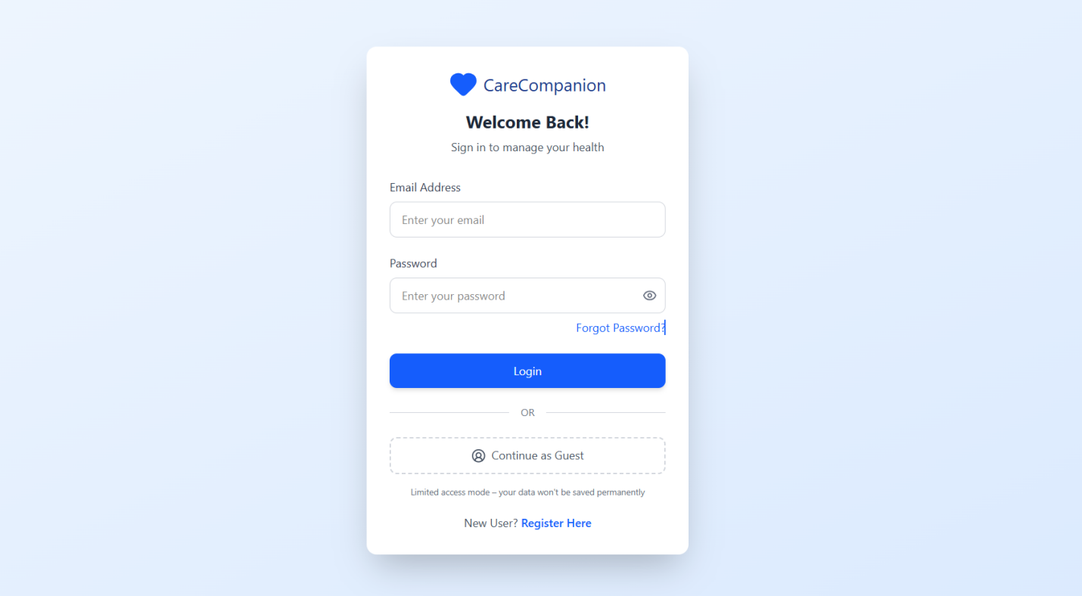
Authentication: The secure login screen featuring email/password fields and an optional "Continue as Guest" mode for temporary, unsaved sessions.

- Screen C.2
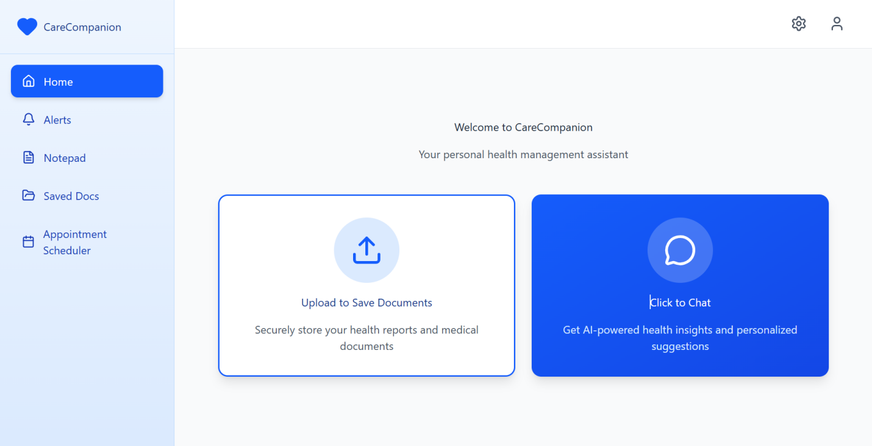
Patient Portal Dashboard: The main home view displaying the side navigation (Home, Alerts, Notepad, Saved Docs, Appointment Scheduler) and distinct quick-action buttons for "Upload to Save Documents" and "Click to Chat."
- Screen C.3
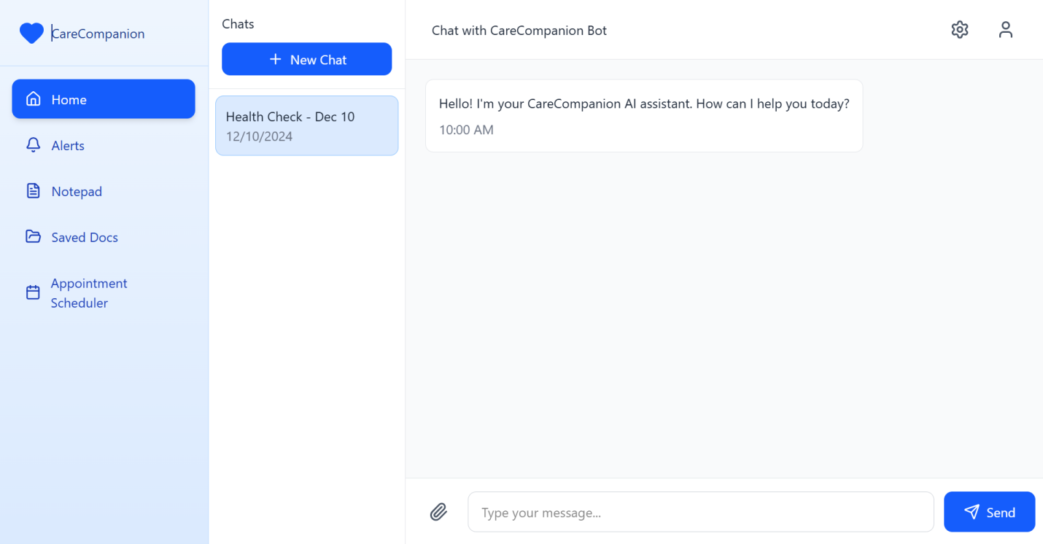
- The Director Chat Interface: The split-screen chat view showing the active conversation window on the right and the patient's chat history/health check logs on the left.

Appendix D — IDP Agent Architecture [NEW v2.0]
★ | The IDP Agent implements the Databricks Hackathon technical stack recommendation:  Orchestration: LangGraph (primary) | LlamaIndex (RAG) | CrewAI (parallel role agents)  ML Lifecycle: MLflow for experiment tracking, sub-task logging, and citation traceability  Vector Store: FAISS (prototype) / LanceDB (production)  Text2SQL: Databricks Genie  Schema Enforcement: Pydantic models per Virtue Foundation schema specification

Agent Reasoning Flow:
- Step 1 — Ingest: load raw facility documents into LlamaIndex vector index (FAISS/LanceDB).
- Step 2 — Retrieve: semantic search retrieves top-k relevant text chunks per query.
- Step 3 — Extract: LLM extracts structured fields (procedure, equipment, capability, specialty) per Pydantic schema.
- Step 4 — Synthesise: merge with structured base fields; resolve conflicts via confidence heuristics.
- Step 5 — Reason: LangGraph orchestrator applies anomaly detection rules and gap analysis logic.
- Step 6 — Cite: every output claim tagged with source document row ID and field name.
- Step 7 — Log: MLflow run records all step I/O, tool calls, and citation indices.
- Step 8 — Output: structured facility profiles, gap report, anomaly flags, and deployment recommendations presented to NGO Coordinator.

Appendix E — Virtue Foundation Facility Schema Summary [NEW v2.0]
Full schema definitions are provided in the Virtue Foundation Schema Documentation. Key field groups:
Field Group | Key Fields | Notes
Organisation Extraction | ngos, facilities, other_organizations | Classify entity type before applying sub-schema
Contact & Web Presence | name, phone_numbers, email, officialWebsite, social links | E164 phone format required
Address | address_line1–3, city, stateOrRegion, country, countryCode | ISO alpha-2 country code required when country known
Facility-Specific | facilityTypeId, operatorTypeId, affiliationTypeIds, numberDoctors, capacity, area | Enum validation enforced by Pydantic
Medical Specialties | specialties (list[str]) | Case-sensitive exact match from specialty hierarchy
Facility Facts (Free-form) | procedure (list[str]), equipment (list[str]), capability (list[str]) | Primary extraction target for IDP Agent — declarative statements with quantities
NGO-Specific | countries, missionStatement, missionStatementLink, organizationDescription | ISO alpha-2 country list

Appendix F — MLflow Citation Traceability Schema [NEW v2.0]
Each MLflow run for an IDP Agent reasoning chain shall log the following parameters and artefacts:
MLflow Field | Description
run_id | Unique identifier for this agent invocation
step_index | Sequential index of reasoning step within run
step_type | Enum: retrieve | extract | synthesise | anomaly_check | gap_analysis | plan
input_query | Natural language query or sub-task prompt for this step
retrieved_row_ids | List of source facility record IDs retrieved from vector store
llm_output | Raw LLM response for this step
structured_output | Pydantic-validated extraction or reasoning output
citation_map | Dict mapping each output claim to its source row_id and field_name
anomaly_flags | List of anomaly objects: {facility_id, severity, conflicting_fields}
eval_metrics | Precision/recall vs. ground-truth schema labels (if eval set available)
timestamp | ISO 8601 timestamp of step execution

Appendix G — Technology Stack Summary
Layer | Component | Version / Notes
Patient Frontend | React | Latest stable; responsive, mobile-compatible
Backend API | Flask + Python | REST API + SocketIO for real-time updates
Admin Dashboard | Streamlit | Quick pipeline monitoring UI
Vision AI | RETFound-Green | Retinal analysis; local GPU execution
Vision AI | ResNet-50 | Anterior segment analysis; ≥85% accuracy target
Image Generation | FLUX.2 (open-source) | 1024×1024 medical illustrations
Video Animation | Wan 2.2 5B (open-source) | 4–5 sec clips at 24 FPS via ComfyUI
Video Editing | FFmpeg + Python | Clip compilation and voiceover mixing
LLM (Chat) | Llama 3.1 via Groq API | Director chat and report synthesis
Database / Auth | Supabase | Cloud PostgreSQL + encrypted storage + RBAC
PDF Parsing | PyPDF2 | Document text extraction
[NEW] IDP Orchestration | LangGraph | Primary agentic workflow graph
[NEW] IDP Orchestration | LlamaIndex | RAG document indexing and retrieval
[NEW] IDP Orchestration | CrewAI | Parallel role-based sub-agent tasks
[NEW] Vector Store | FAISS / LanceDB | Semantic similarity retrieval for facility docs
[NEW] ML Lifecycle | MLflow | Experiment tracking, citation logging, eval metrics
[NEW] Text2SQL | Databricks Genie | NL → SQL for structured facility data queries
[NEW] Schema Validation | Pydantic | Enforce Virtue Foundation facility schema
[NEW] Map Visualisation | Leaflet.js / Folium | Interactive geospatial facility and gap maps

.
5. Technology Stack
- Frontend (Patient Portal): React for a clean, easy-to-use patient screen.
- Backend (API & Rules): Flask and Python to manage the data and routing.
- Admin Dashboard: Streamlit to build quick screens to watch the AI run.
- AI Core: PyTorch to run the vision models.
- Media Tools:
  - Pictures: FLUX.2 (Open Source).
  - Video: Wan 2.2 5B Model (Open Source) using ComfyUI and WanVideoWrapper.
  - Video Editing: FFmpeg with Python

